Consumption and Operation Monitoring Dashboard

Overview
Many of our customers have established monitoring mechanisms using 3rd-party tools such as Splunk, PagerDuty, Tableau, or other tools. We can build queries by writing queries to pull the information from Snowflake.Account_usage views. As an RSA, I’ve found good value in building dashboards in Snowsight to help customer see the performance metrics and to communicate issues.

Operational Dashboard - Credits and Query Counts

Credit Usage

Credits - Used vs Billed
Information showing:
Column Name | Description
credits_billed | Total number of credits billed for the account in the day. This is a sum of CREDITS_USED_COMPUTE, CREDITS_USED_CLOUD_SERVICES, and CREDITS_ADJUSTMENT_CLOUD_SERVICES.
credits_used | Sum of CREDITS_USED_COMPUTE and CREDITS_USED_CLOUD_SERVICES.
credits_used_compute | Number of credits billed for virtual warehouses.
credits_used_cloud_services | Number of credits billed for cloud services.
credits_used_billed_cs | Sum of CREDITS_USED_CLOUD_SERVICES and CREDITS_ADJUSTMENT_CLOUD_SERVICES Billed.
= Total number of credits billed for the account in the day.
credits_used= Sum of CREDITS_USED_COMPUTE and CREDITS_USED_CLOUD_SERVICES.
Please note that =:daterange should be changed to a range that is desired.
Possibly many dashboards with different time ranges can be created to identify more or less granular information.
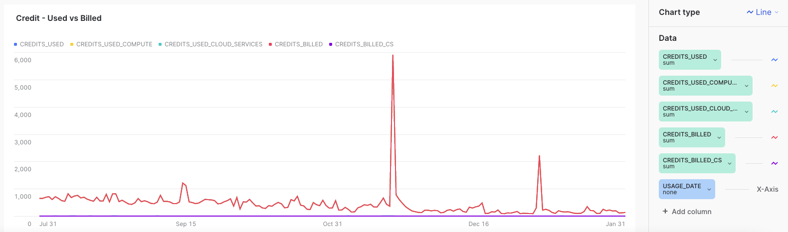

select USAGE_DATE
, CREDITS_USED
, CREDITS_USED_COMPUTE
, CREDITS_USED_CLOUD_SERVICES
, CREDITS_BILLED
, case when CREDITS_BILLED - CREDITS_USED_COMPUTE > 0 then CREDITS_BILLED - CREDITS_USED_COMPUTE else 0 end as CREDITS_BILLED_CS
FROM ACCOUNT_USAGE.METERING_DAILY_HISTORY
where USAGE_DATE =:daterange
ORDER BY USAGE_DATE;
Here is the query, modified to use Organizations feature to include all the accounts for the same customer
select Account_name
, USAGE_DATE
, service_type
, CREDITS_USED
, CREDITS_USED_COMPUTE
, CREDITS_USED_CLOUD_SERVICES
, CREDITS_BILLED
, case when CREDITS_BILLED > CREDITS_USED_COMPUTE then CREDITS_BILLED - CREDITS_USED_COMPUTE else 0 end as CREDITS_BILLED_CS
FROM Organization_usage.PREVIEW_METERING_DAILY_HISTORY
where USAGE_DATE =:daterange
ORDER BY USAGE_DATE;

Last 6 Months Credits
showing monthly for completed months:
Column Name | Description
credits_billed | Total number of credits billed for the account in the day. This is a sum of CREDITS_USED_COMPUTE, CREDITS_USED_CLOUD_SERVICES, and CREDITS_ADJUSTMENT_CLOUD_SERVICES.
credits_used | Sum of CREDITS_USED_COMPUTE and CREDITS_USED_CLOUD_SERVICES.
credits_used_compute | Number of credits billed for virtual warehouses.
credits_used_cloud_services | Number of credits billed for cloud services.
credits_used_billed_cs | Sum of CREDITS_USED_CLOUD_SERVICES and CREDITS_ADJUSTMENT_CLOUD_SERVICES Billed.

select USAGE_DATE, CREDITS_USED, CREDITS_USED_COMPUTE, CREDITS_USED_CLOUD_SERVICES, CREDITS_BILLED, case when CREDITS_BILLED - CREDITS_USED_COMPUTE > 0 then CREDITS_BILLED - CREDITS_USED_COMPUTE else 0 end as CREDITS_BILLED_CS
FROM ACCOUNT_USAGE.METERING_DAILY_HISTORY
where USAGE_DATE between DATEADD(MONTH, -6, DATEADD(day, -1, date_trunc('month', current_timestamp())))
and DATEADD(day, -1, date_trunc('month', current_timestamp()))
ORDER BY USAGE_DATE;
Here is the query, modified to use Organizations feature to include all the accounts for the same customer.
select account_name, USAGE_DATE, CREDITS_USED, CREDITS_USED_COMPUTE, CREDITS_USED_CLOUD_SERVICES, CREDITS_BILLED, case when CREDITS_BILLED > CREDITS_USED_COMPUTE then CREDITS_BILLED - CREDITS_USED_COMPUTE else 0 end as CREDITS_BILLED_CS
FROM ORGANIZATION_USAGE.PREVIEW_METERING_DAILY_HISTORY
where USAGE_DATE between DATEADD(MONTH, -6, DATEADD(day, -1, date_trunc('month', current_timestamp())))
and DATEADD(day, -1, date_trunc('month', current_timestamp()))
ORDER BY USAGE_DATE;

Credits by Warehouse

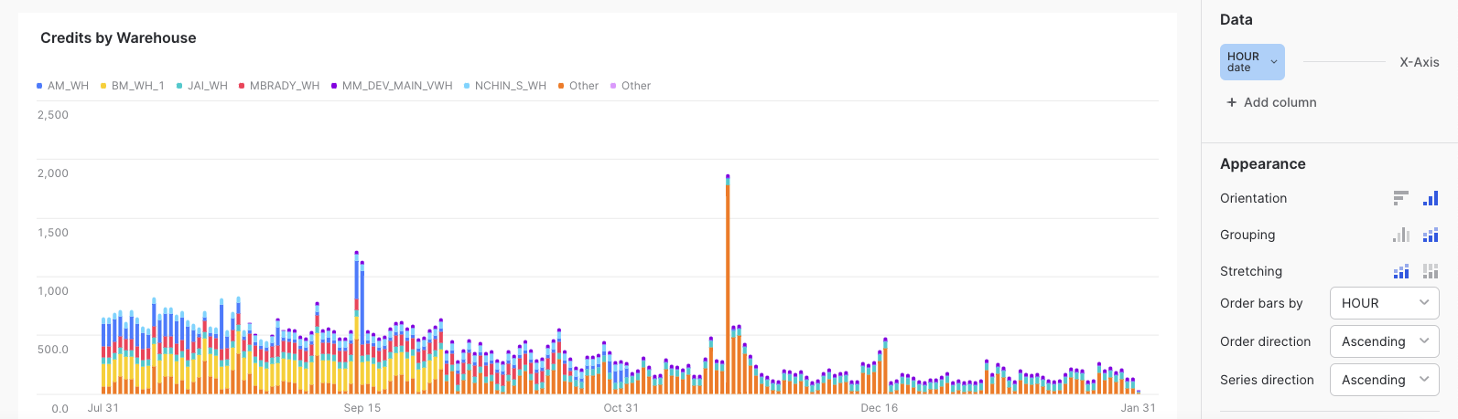
showing compute credits used per warehouse (top 10) and sum the rest of the warehouse together as “Other”.
select coalesce(top_warehouse, case when warehouse_name='CLOUD_SERVICES_ONLY' then 'CLOUD_SERVICES_ONLY' else 'Other' end ) as warehouse_name
, start_time as hour
, warehouse_name as _warehouse_name
, CREDITS_USED, CREDITS_USED_COMPUTE
, CREDITS_USED_CLOUD_SERVICES
FROM ACCOUNT_USAGE.WArehouse_metering_HISTORY h
left join
(select
warehouse_name as top_warehouse
from snowflake.account_usage.WAREHOUSE_METERING_HISTORY
where start_time = :daterange
group by warehouse_name
order by sum(credits_used) desc
limit 10 ) t
on top_warehouse = warehouse_name
where start_time = :daterange
ORDER BY hour, warehouse_name;

Cloud Service Credits by Warehouse
showing top 10 warehouse that the queries are targeting, plus the warehouse called “cloud_services_only” and the rest of the warehouses summed up as “Other”.

select coalesce(top_warehouse, case when warehouse_name='CLOUD_SERVICES_ONLY' then 'CLOUD_SERVICES_ONLY' else 'Other' end ) as warehouse_name, start_time as hour, warehouse_name as _warehouse_name, CREDITS_USED, CREDITS_USED_COMPUTE, CREDITS_USED_CLOUD_SERVICES
FROM ACCOUNT_USAGE.WArehouse_metering_HISTORY h
left join
(select warehouse_name as top_warehouse
from snowflake.account_usage.WAREHOUSE_METERING_HISTORY
where start_time = :daterange
group by warehouse_name
order by sum(CREDITS_USED_CLOUD_SERVICES) desc
limit 10 ) t
on top_warehouse = warehouse_name
where start_time = :daterange
ORDER BY hour, warehouse_name;

Cloud Service Credits by User
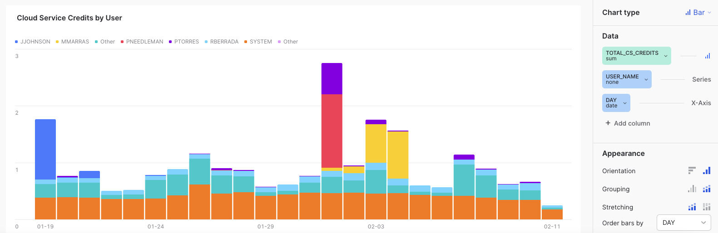

with tmp as
(
select user_name, sum(credits_used_cloud_services) as total_cs_credits
from account_usage.query_history
where start_time =:daterange
group by 1
order by 2 desc
limit 10
)
select warehouse_name, ifnull(tmp.user_name, 'Other') as user_name
, date_trunc('day', start_time) as day
, sum(credits_used_cloud_services) as total_cs_credits
, avg(credits_used_cloud_services) as avg_cs_credits
from account_usage.query_history q
left join tmp
on q.user_name = tmp.user_name
where start_time =:daterange
group by 1, 2, 3
order by 1, 2, 3
;

Cloud Services used by Query Type
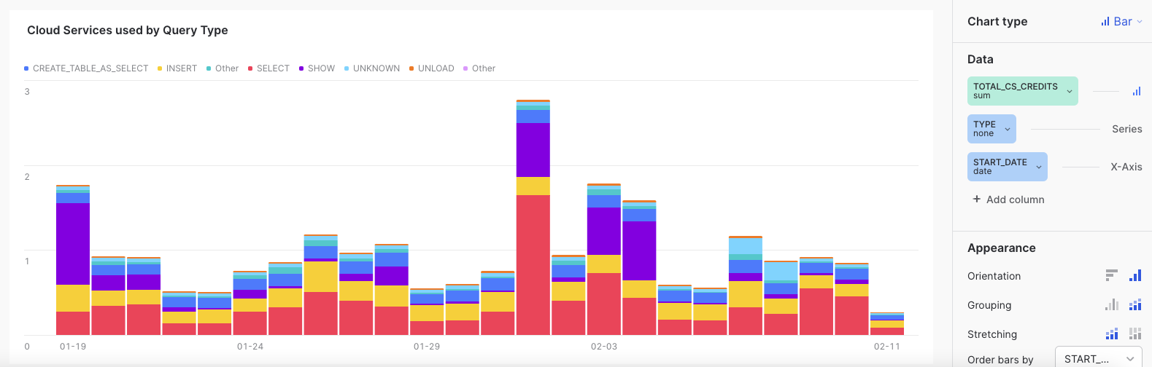
with tmp as
(
select warehouse_name
,user_name
, strtok(query_type, 1) as query_type
, date_trunc('day', start_time) as start_date
, CREDITS_USED_CLOUD_SERVICES
from account_usage.query_history
where start_time=:daterange
)
, tmp2 as
(
select start_date, query_type, count(*), sum(CREDITS_USED_CLOUD_SERVICES) as total_CS_CREDITS, avg(CREDITS_USED_CLOUD_SERVICES) as avg_CS_CREDITS
from tmp
group by 1, 2
)
, tmp3 as
(
select query_type, sum(total_CS_CREDITS) total_CREDITS
from tmp2
group by 1
order by total_CREDITS desc
limit 10
)
select start_date, ifnull(b.query_type, 'Other') as type, count(*) as query_count, sum(CREDITS_USED_CLOUD_SERVICES) as total_CS_CREDITS, avg(CREDITS_USED_CLOUD_SERVICES) as avg_CS_CREDITS
from tmp a
left join tmp3 b
on a.query_type = b.query_type
group by 1, 2;

Query Count

Query Count by Warehouse
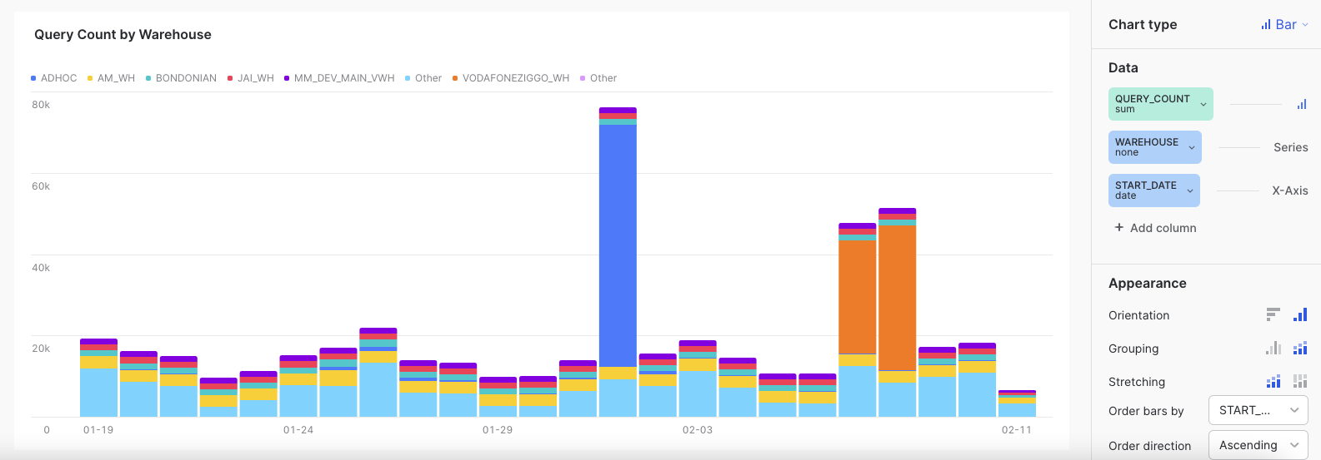

with tmp as
(
select warehouse_name
, date_trunc('day', start_time) as start_date
from account_usage.query_history
where start_time=:daterange
)
, tmp2 as
(
select warehouse_name, count(*)
from tmp
group by 1
order by 2 desc
limit 10
)
select start_date, ifnull(b.warehouse_name, 'Other') as warehouse, count(*) as query_count
from tmp a
left join tmp2 b
on a.warehouse_name = b.warehouse_name
group by 1, 2;

Query Count by User
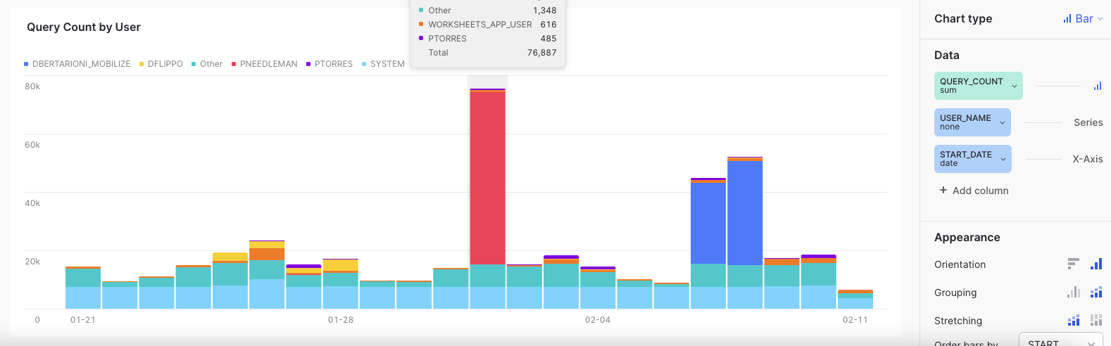

with tmp as
(
select user_name
, date_trunc('day', start_time) as start_date
from account_usage.query_history
where start_time=:daterange
)
, tmp2 as
(
select user_name, count(*)
from tmp
group by 1
order by 2 desc
limit 10
)
select start_date, ifnull(b.user_name, 'Other') as user_name, count(*) as query_count
from tmp a
left join tmp2 b
on a.user_name = b.user_name
group by 1, 2

Query Count by Query Type
Here we combine all the similar query types into one.
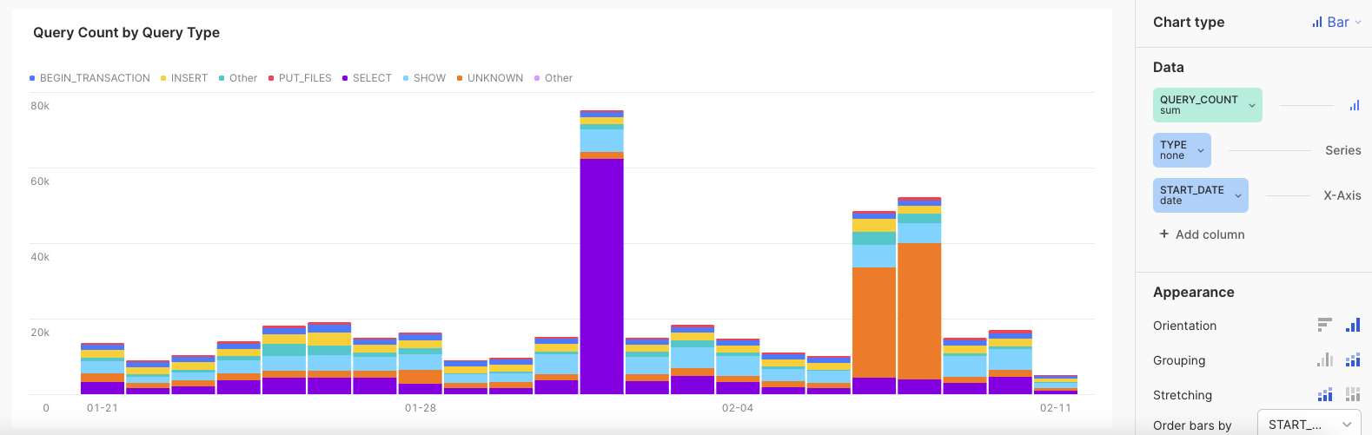

with tmp as
(
select strtok(query_type, 1) as query_type -- Here we combine all the similar query types into one
, date_trunc('day', start_time) as start_date
from account_usage.query_history
where start_time=:daterange
)
, tmp2 as
(
select query_type, count(*)
from tmp
group by 1
order by 2 desc
limit 10
)
select start_date, ifnull(b.query_type, 'Other') as type, count(*) as query_count
from tmp a
left join tmp2 b
on a.query_type = b.query_type
group by 1, 2;

COPY Metrics

Overall COPY - Rows Loaded by Database
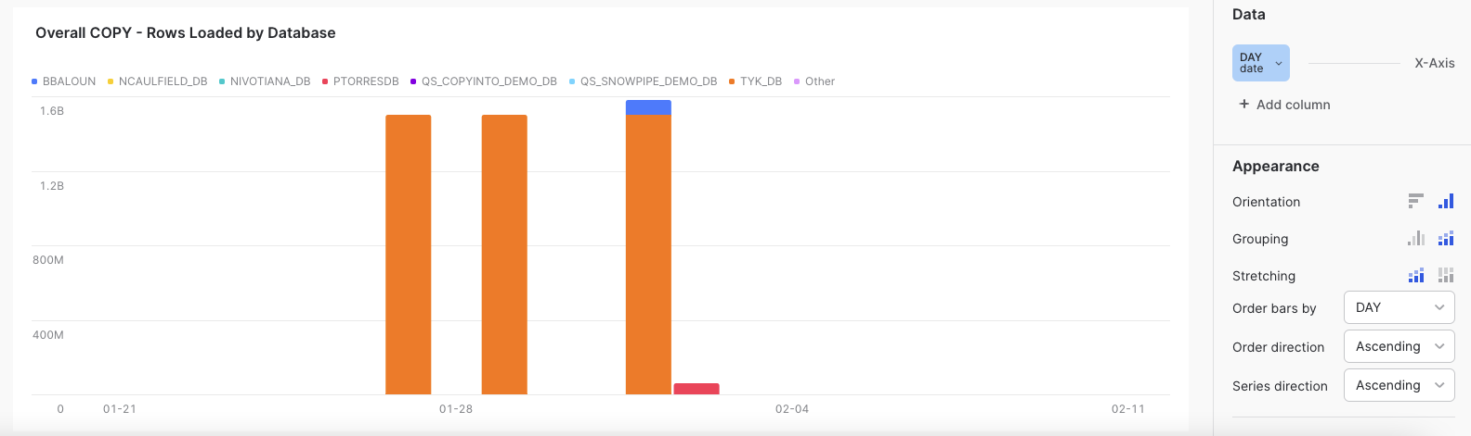
with tmp as
(
select sum(ROW_COUNT) as rows_loaded
, TABLE_CATALOG_NAME
from account_usage.copy_history
where last_load_time = :daterange
group by TABLE_CATALOG_NAME
order by rows_loaded desc
limit 10
)

select
ifnull(tmp.TABLE_CATALOG_NAME, 'Other') as "Database"
, date_trunc(day,last_load_time) as day
, count(*) as total_copy_jobs
, sum(case when error_count > 0 then 1 else 0 end) as error_jobs
, sum(ROW_COUNT) as rows_loaded
, sum(file_size) / power(1024, 2) as total_MB_loaded
, sum(file_size) / power(1024, 3) as total_GB
from account_usage.copy_history c
left join tmp
on c.TABLE_CATALOG_NAME =tmp.TABLE_CATALOG_NAME
where last_load_time =:daterange
group by 1, 2
order by 1, 2
;

Overall COPY - GB Loaded by Database
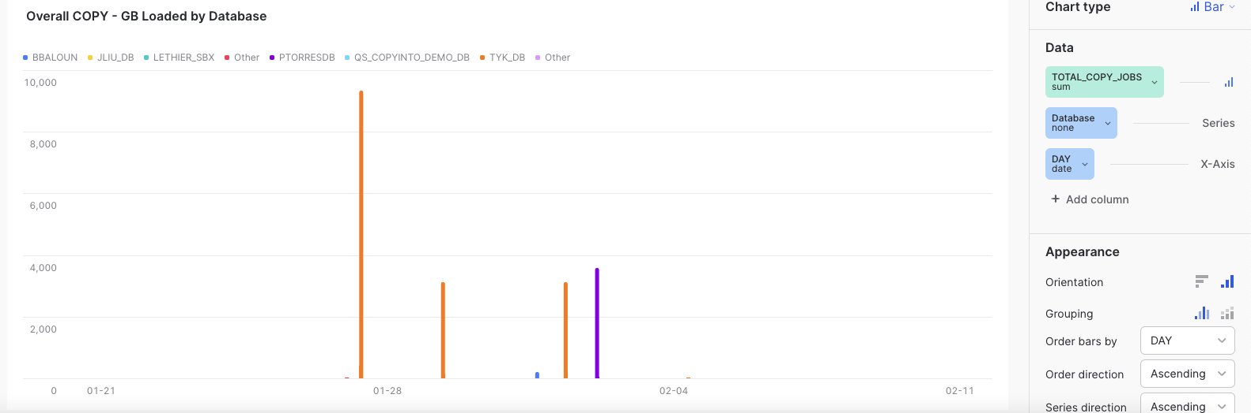
with tmp as
(
select sum(file_size) as total_bytes_loaded
, TABLE_CATALOG_NAME
from account_usage.copy_history
where last_load_time = :daterange
group by TABLE_CATALOG_NAME
order by total_bytes_loaded desc
limit 10
)
select
ifnull(tmp.TABLE_CATALOG_NAME, 'Other') as "Database"
, date_trunc(day,last_load_time) as day
, count(*) as total_copy_jobs
, sum(case when error_count > 0 then 1 else 0 end) as error_jobs
, sum(ROW_COUNT) as rows_loaded
, sum(file_size) / power(1024, 2) as total_MB_loaded
, sum(file_size) / power(1024, 3) as total_GB
from account_usage.copy_history c
left join tmp
on c.TABLE_CATALOG_NAME =tmp.TABLE_CATALOG_NAME
where last_load_time =:daterange
group by 1, 2
order by 1, 2
;

Additional Tiles

Warehouse Queries by Execution Time
This query can be shown in 2 tiles, side-by-side, showing the stretched and unstretched views.
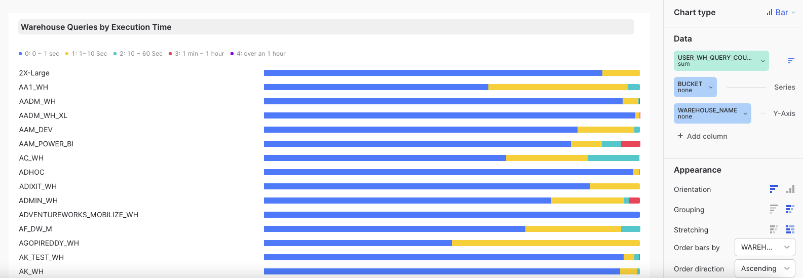

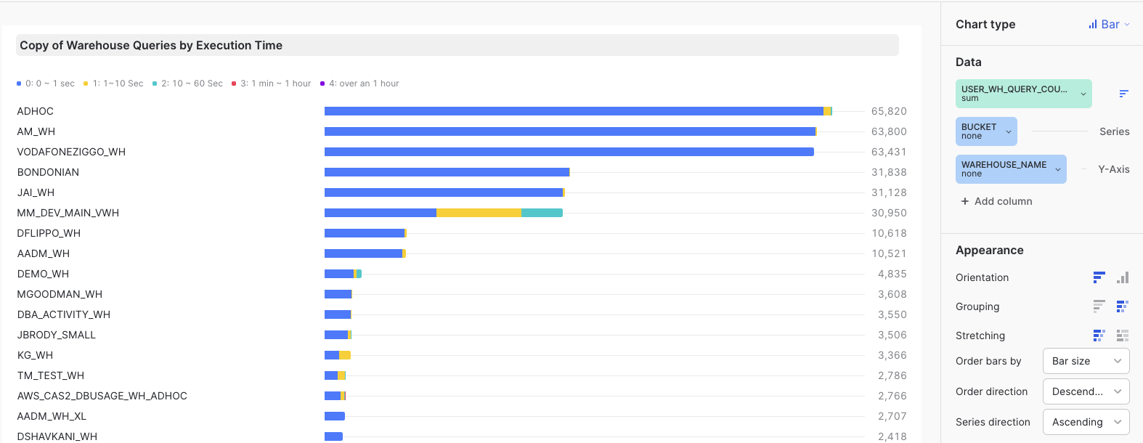

with raw as
(
select
query_text,
session_id,
start_time,
warehouse_name,
user_name,
query_id,
execution_time,
BYTES_SPILLED_TO_LOCAL_STORAGE, -- Local spill
BYTES_SPILLED_TO_REMOTE_STORAGE, -- Remote spill
queued_overload_time+queued_provisioning_time+queued_repair_time as queue_time,
case when execution_time < 1000 then '0: 0 ~ 1 sec'
when execution_time >= 1000 and execution_time < 10000 then '1: 1~10 Sec'
when execution_time >= 10000 and execution_time <= 60000 then '2: 10 ~ 60 Sec'
when execution_time > 60000 and execution_time <= 3600000 then '3: 1 min ~ 1 hour'
when execution_time > 3600000 then '4: over an 1 hour'
end as bucket,
count(*) over (partition by warehouse_name) as total_count,
TOTAL_ELAPSED_TIME
from snowflake.account_usage.query_history j
where j.start_time = :daterange
)
select warehouse_name, bucket
, any_value(total_count) as WH_query_count
, count(*) as user_WH_query_count
, user_WH_query_count * 100 / WH_query_count as percentage
, avg(TOTAL_ELAPSED_TIME) /1000as avg_total_runtime_secs
, avg(execution_time) /1000 as avg_WH_secs
, max(TOTAL_ELAPSED_TIME) /1000as max_total_runtime_secs
, max(execution_time) /1000 as max_WH_secs
, avg(queue_time) /1000 as avg_queue_time
, max(queue_time) /1000 as max_queue_time
, avg(BYTES_SPILLED_TO_REMOTE_STORAGE) / power(1024, 2) as avg_mb_spill_remote
, avg(BYTES_SPILLED_TO_LOCAL_STORAGE) / power(1024, 2) as avg_mb_spill_local
, any_value(query_id) as example_query_id
from raw
group by 1, 2
order by 1, 2
;

Operational Dashboard - Copy History

Top Tables
This tile shows the top 50 tables in the account, based on the current total combined size, including time travel, etc.
It can be displayed as bar graph or a table.
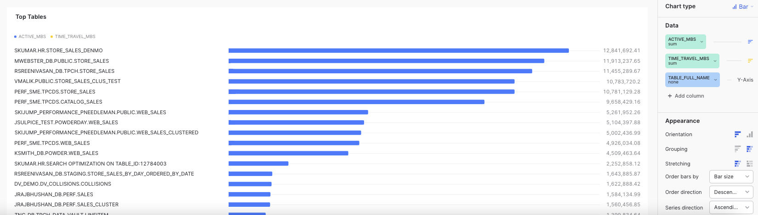

select
row_number() over ( order by active_bytes+time_travel_bytes+failsafe_bytes+retained_for_clone_bytes desc) as Rank_No
, table_catalog as db_name, table_schema as schema_name, table_name
, table_catalog || '.' || table_schema || '.' || table_name as table_full_name
, is_transient
, iff(ID = CLONE_GROUP_ID, 0, 1) as is_a_clone
, TO_NUMBER((active_bytes+time_travel_bytes+failsafe_bytes+retained_for_clone_bytes) / power(1024, 2), 32, 2) as total_mbs
, TO_NUMBER(active_bytes / power(1024, 2), 32, 2) as active_mbs
, TO_NUMBER(time_travel_bytes / power(1024, 2), 32, 2) as time_travel_mbs
, TO_NUMBER(failsafe_bytes / power(1024, 2), 32, 2) as failsafe_mbs
, TO_NUMBER(retained_for_clone_bytes / power(1024, 2), 32, 2) as retained_for_clone_mbs,
table_created
from account_usage.table_storage_metrics
where deleted = 0
order by total_mbs desc
limit 50;

Approximate Calculation of Most Expensive Queries
The following script display the queries that are deemed "most-expensive" by calculating

<# of times run> times <execution time> times <warehouse size>

The code query_text hash to identify the same query running multiple times. We exclude the COPY and INSERT statement, as well as the metadata queries. This can be turned into a stored procedure or a view

Total Weight will signal the queries that in the last 7 days had same pattern (same query ran multiple times) and used the most credits.

This query is best looked at in a table format.

with temp as
(select execution_time
, query_id
, error_code
, hash(REGEXP_REPLACE(query_text, '([0-9])|(''[^'']*'')', '?')) as sql_hash
, case when warehouse_size ='X-Small' then 1
when warehouse_size ='Small' then 2
when warehouse_size ='Medium' then 4
when warehouse_size ='Large' then 8
when warehouse_size ='X-Large' then 16
when warehouse_size ='2X-Large' then 32
when warehouse_size ='3X-Large' then 64
when warehouse_size ='4X-Large' then 128
else 0 end as server_count
, query_type
, warehouse_name
, query_text
, warehouse_size
, user_name
, PARTITIONS_TOTAL
, PARTITIONS_SCANNED
, start_time
, ROWS_INSERTED
from "SNOWFLAKE"."ACCOUNT_USAGE"."QUERY_HISTORY"
where 1=1
and warehouse_size is not null
and start_time >= Dateadd('day', -7, current_timestamp())
and execution_time > 0
and trim(query_text) not ilike 'call %' -- remove stored prod
)
, base as
(
select sql_hash
, any_value(user_name) as example_user_name
, any_value(warehouse_name) as example_warehouse_name
, count(*) as total_times_run
, count(error_code) as total_times_failed
, iff(total_times_failed > 0, round(total_times_failed * 100 / total_times_run, 2), null) as failure_ratio
, case when sum(PARTITIONS_TOTAL) > 0 then sum(PARTITIONS_SCANNED) * 100 / sum(PARTITIONS_TOTAL) else null end as avg_pruning_ratio
, sum(server_count * execution_time) as total_weight
, avg(execution_time) /1000 as avg_execution_sec
, avg(server_count) as warehouse_size
, any_value(query_type) as query_type
, any_value(query_id) as example_query_id
, any_value(query_text) as example_query_text
from temp
where query_type not in ('COPY')
group by sql_hash
)
select example_user_name
, example_warehouse_name
, total_times_run
, total_times_failed
, failure_ratio
, avg_pruning_ratio
, total_weight
, avg_execution_sec
, warehouse_size
, query_type
, example_query_id
, example_query_text
from base

having total_times_run > 6
order by total_weight desc LIMIT 50;

